|  |  |
| --- | --- |
| Mohamed Mahfoudh Preparatory School | Date: May, 28th 2016 |
| School – year : 2015 – 2016 | Level: 7th Form 3&7 |
| *Teacher: Mrs Senda Kshaw* | |
| Name: ………………......................... Class:………………n°: …………Mark:........../20 | |

**English Full-Term Test N° 2**

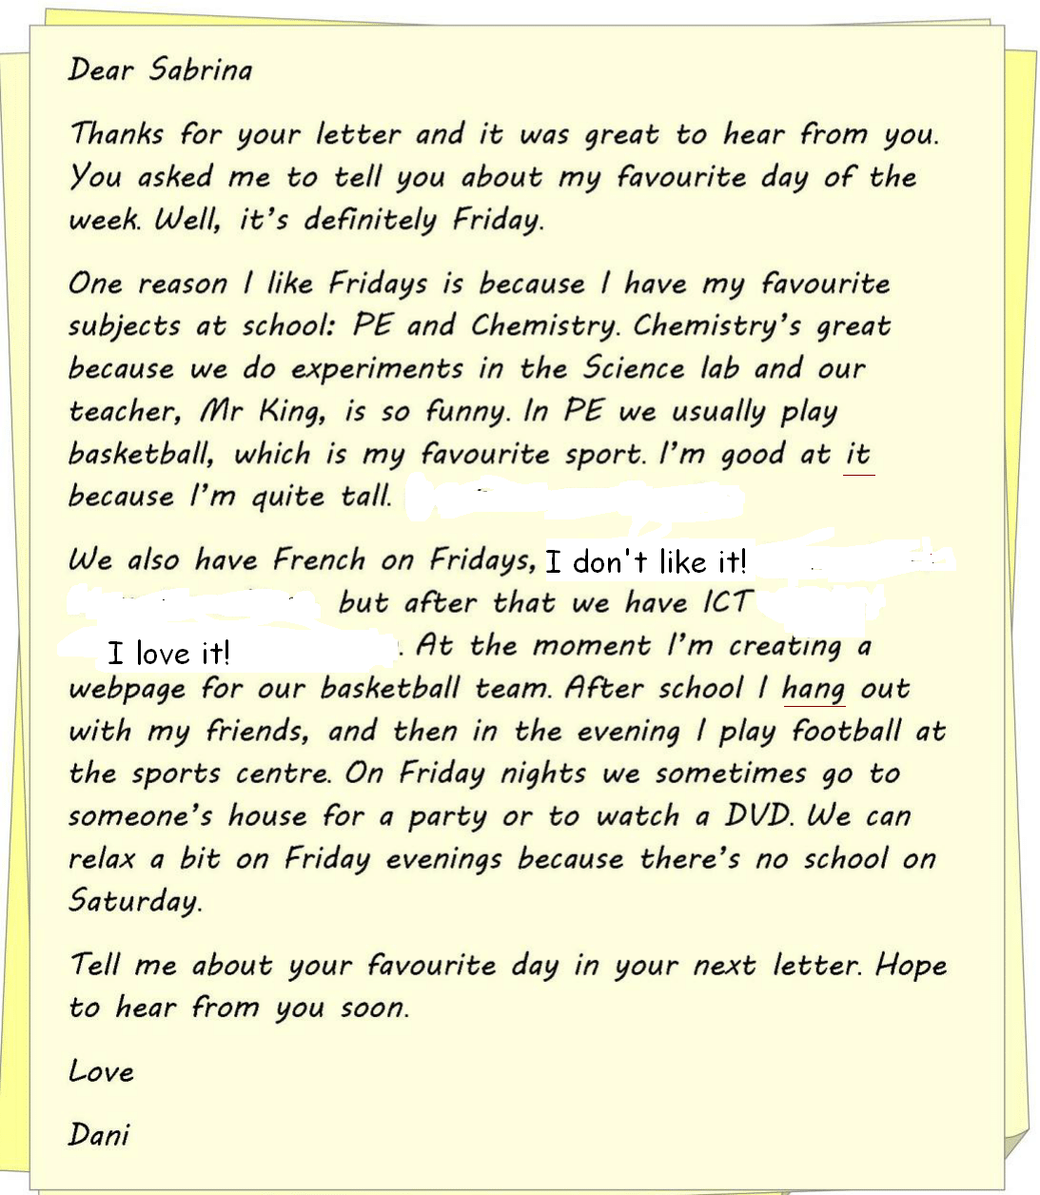

**The text is adapted from** :[**http://learnenglishteens.britishcouncil.org/skills/writing-skills-practice/letter-friend**](http://learnenglishteens.britishcouncil.org/skills/writing-skills-practice/letter-friend)

1. **Reading comprehension: (5 Marks):**
2. **Tick (** ✓**) the right option:(1 Mark)**

The letter is about: ☞Dani’s family**⁯**

☞Dani’s favourite day

☞Dani’s bestfriends

1. **What  are Dani’s favourite subjects?(1mark)**…………………………………………………………………………………………………………………………………………
2. **What does Dani do on Friday evening ?(1 mark)**

………………………………………………………………………………………………………………………………………………

1. **Tick ( ✓) the right option (1mark)**go around

“Hang out “( paragraph 3) means :Go to school

Go to sleep

1. **What does the underlined word refer to?( 1 mark)**

“it” (paragraph2) refers to..........................................................

1. **Language: (10 Marks):**
2. **Fill in the blanks with words from the box.There are 2 extra words.(4 marks)**

And/are/voluntary/subjects/favourite/at/study /water/marks/nice



My name is Elena and I'm a pupil of the 7th form. I ----------at school . I would like to tell you a few words about my school life.

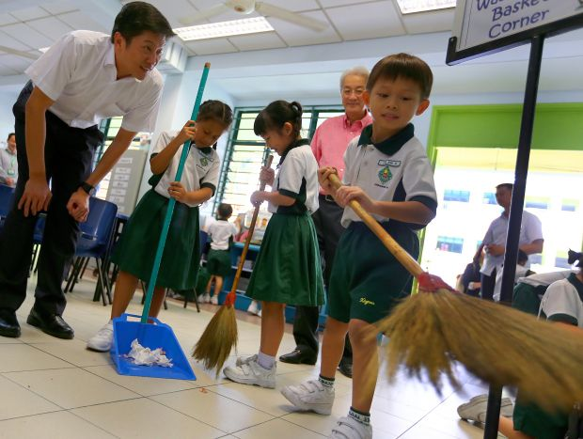I go to school five days a week except Saturday and Sunday . Classes in our school start ----------8 o'clock in the morning and last till 14.30. We have 6 or 7 lessons a day. We study a lot of different ----------- :English, History, Geography, Biology, Physics, Chemistry, Math, etc. I like History,--------------- English . I usually have good ---------in these subjects.   
Our school is old. Our classroom is nice. There -----------many flowers in the courtyard. It is pupils of our class who are responsible to ------------ the flowers  
I like going to school because my teachersare--------------and friendly**. Adapted from**:<http://www.englishtopics.net/topicsmenu/1-topicsforbeginners/76-my-school-life>

1. **Circle the correct option (3,5 marks)**

**I am (to teach/teach/teaching )in Japanese schools.In Japan, pupils clean (them/their/they)**classrooms and schools each day. Japanese pupils are responsible for **(keeping/keep/to keep)** the school and classroomsclean.

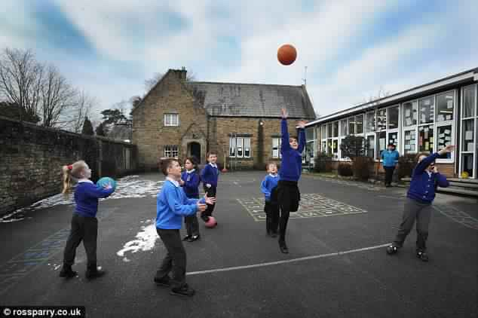At my schools, all students clean at the same time usually **(on/at/in)** the morning at 10:10am. At lunch time, the students clean their tables**(to/too/two).**These cleaning activities create a sense of **(responsibility/responsible/responsibling)** and a way to teach children the importance of a clean **(countryside/environment/couryard).Adapted from** :<https://eslkevin.wordpress.com/2011/03/15/students-keeping-their-own-schools-clean-taiwan/>

1. **Put the bracketed words in the right tense/form (2,5 marks)**I lived in a small and beautiful village. I **(go)** -----------to a Primary School when I **(be)**--------five.I liked it. Our teacher was very kind and**(help)**------------------

I studied all the subjects equally. But mathematics was my favourite subject. I liked (**play)**------------------sports andI **(participate)** ---------------- in football matches at school too

**Adapted from** : <http://essay-letter-writing.blogspot.com/2013/12/my-school-life-or-memories-of-school.html>

1. **Writing ( 5 marks):**

**Use the information in the table to write a letter to your friend Dani todescribe your school:**

|  |  |  |  |  |  |
| --- | --- | --- | --- | --- | --- |
| Name of school | Number of classrooms/labs | courtyard | subjects | Favourite subject | Favourite teacher |
| Mahfooth | 18classrooms/6 labs | Small | French/Arabic/math…… | ………………. | ……………………. |

Dear Dani,

Sfax ,May 28th ,2016

-------------------------------------------------------------------------------------------------------------------------------------------------------------------------------------------------------------------------------------------------------------------------------------------------------------------------------------------------------------------------------------------------------------------------------------------------------------------------------------------------------------------------------------------------------------------------------------------------------------------------------------------------------------------------------------------------------------------------------------------------------------------------------------------------------------------------------------------------------------------------------------------------------------------------------------------------------------------------------------------------------------------------------------------------------------------------------------------------------------------------------------------------------------------------------------------------------------------------------------------------------------------------------------------------------------------------------------------------------------------------------------------------------------------------------------------------------------------------------------------------------------------------------------------------------------------------------------------------------------------------------------------------------------------------------------------------------------------------------------------------------------------------------------------------------------------------------------------------

